APPLECROSS SENIOR HIGH SCHOOL
3A/3B HUMAN BIOLOGOLGICAL SCIENCES
TEST 3:
NERVOUS SYSTEM AND ENDOCRINE SYSTEM

DO NOT MARK THIS PAPER IN ANY WAY

Time Allowed: All Period

PART A. Answer questions 1 to 30 on the multiple choice answer sheet provided by marking the letter corresponding to the BEST alternative

- The part of the nervous system which produces the “fight or flight” response is the
(a) central nervous system
(b) parasympathetic system
(c) peripheral nervous system
(d) sympathetic system
- Which of the following symptoms would a person with a degenerative disease of the cerebellum be most likely to show?
(a) Loss of peripheral vision
(b) Reduced motor co-ordination
(c) Difficulty hearing high pitched sounds
(d) Loss of long term memory
- The regulation of breathing and heart rate involves neurons cell bodies that lie in the:
(a) cerebrum
(b) spinal cord
(c) medulla
(d) thalamus
4. Of the following, the hormone NOT secreted by the anterior lobe of the pituitary is:

(a) ACTH.
(b) prolactin.
(c) thyrotrophic hormone (TSH or Thyroid stimulating hormone).
(d) ADH.

5. There are THREE phases in the secretion of gastric juice in the stomach. In the first phase, gastric juice is secreted when food is seen, smelt or tasted. In the second phase, the presence of food in the stomach stimulates the secretion of gastric juice. In the third phase, the presence of partially digested food in the small intestine results in a decrease in the secretion of gastric juice.
If the nerve to the stomach is cut, the first phase ceases but the second and third phases continue. This indicates that secretion of gastric juice is under:
(a) nervous control
(b) hormonal control
(c) both nervous and hormonal control
(d) neither nervous nor hormonal control
6. Consider the diagram below of a nerve cell.
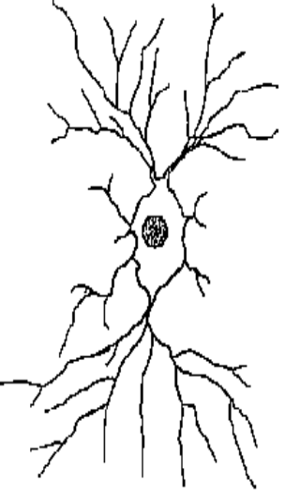
Figure 1. Nerve cell
The type of nerve cell illustrated in the diagram above is found in:
(a) the grey matter of the brain
(b) the white matter of the spinal cord
(c) the cochlea of the ear
(d) touch receptors in the skin.

7. Nervous coordination generally differs from endocrine coordination. Compared with endocrine coordination, nervous coordination is generally:
(a) slower
(b) less specific
(c) faster
(d) controlled by hormones.

- One main function of cerebrospinal fluid is to:
(a) aid in the transmission of sensory impulses in the cerebral cortex
(b) help lubricate the intervertebral discs
(c) aid in protection of the brain and spinal cord
(d) transmit nerve impulses from inside the brain to other areas of the body.
9. Under-activity of the thyroid gland would result in increased:

(a) sensitivity to cold.
(b) appetite for food.
(c) nervous excitability.
(d) body weight.

10. The autonomic nervous system is responsible for:
(a) higher brain functions
(b) co-ordination of muscular activity
(c) involuntary control of our internal environment
(d) voluntary control of respiration
11. The parathyroid glands produce a hormone called parathormone, which acts on various parts of the body resulting in an increase in the concentration of blood calcium. As the blood calcium level increases, the production of parathormone decreases.
It would be unreasonable to conclude that a fall in blood calcium level would result in an increase in:
(a) secretion of parathormone
(b) absorption of calcium from the alimentary canal
(c) release of calcium from bone tissue
(d) excretion of calcium by the kidneys.
12. Which of the following statements BEST describes homeostasis?

- Homeostasis maintains the core body temperature at a constant level.
- Homeostatic mechanisms make the body relatively independent of external changes.
- Thirst and hunger are homeostatic mechanisms.
- Homeostasis ensures that cells always function at their optimum level.

13. Which of the following is the correct sequence of events and structures that are involved in a steady state control system?

- Stimulus → effector → receptor → modulator → response → feedback
- Stimulus → receptor → modulator → effector → response → feedback
- Stimulus → response → receptor → modulator → effector → feedback
- Feedback → stimulus → effector → modulator → receptor → response

14. Receptors are:

- nerve centres in the spinal cord.
- centres in the brain that receive nerve impulses.
- specialised nervous tissue sensitive to changes in our surroundings.
- nerves that conduct impulses within the central nervous system.

Question 15 refers to the diagram below of a nerve cell (neuron).

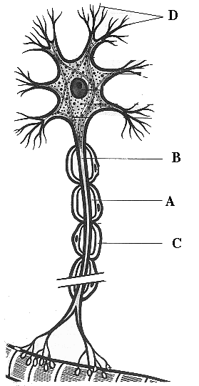

Figure 2. Nerve cell

15. In the diagram

- A is the neurilemma, B is the axon, C is the myelin sheath, D is a dendrite.
- A is the neurilemma, B is the myelin sheath, C is a dendrite, D is the axon.
- A is the myelin sheath, B is the axon, C is the neurilemma, D is a dendrite.
- A is the myelin sheath, B is the dendrite, C is the neurilemma, D is an axon.

16. Myelination of a nerve fibre

- causes a slower conduction of nerve impulses along the fibre.
- prevents the nerve impulses from jumping along the fibre.
- slows the fibre’s return to normal following conduction of an impulse.
- speeds up the passage of nerve impulses along the fibre.

17. The point where a nervous impulse is transferred from a neuron to a muscle fibre is called the

- synapse.
- neurotransmitter.
- Nodes of Ranvier
- interneuron.

18. What are the correct labels for the boxes labelled (A) and (B)?

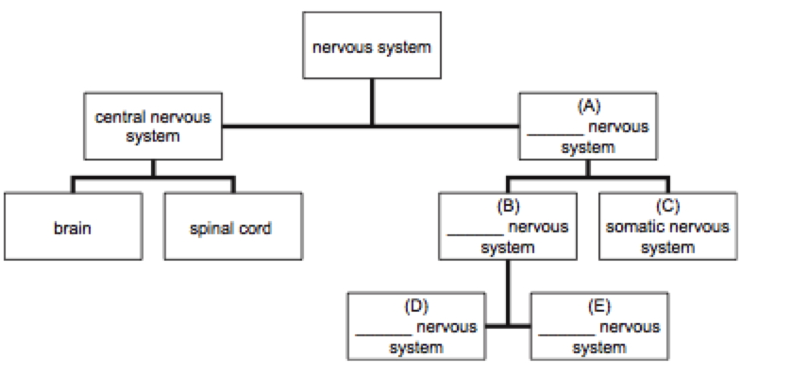
Figure 3. Nervous System divisions

(a) sympathetic; parasympathetic
(b) peripheral; autonomic
(c) sympathetic; peripheral
(d) parasympathetic; autonomic

19. The cerebral cortex

(a) acts as a protective layer covering the brain.
(b) connects the right hemisphere with the left hemisphere.
(c) is responsible for voluntary muscle movements.
(d) increases the strength of the immune system.

20. Which of the following statements about neurons is correct?

(a) afferent neurons make the connection between motor and sensory neurons
(b) efferent neurons make the connection between motor and sensory neurons
(c) afferent neurons carry information from the sensory organs to the central nervous system
(d) efferent neurons carry information from the sensory organs to the central nervous system

21. When the sympathetic nervous system is activated, which of the following changes occur in the body?

(a) the blood pressure decreases and the pupils dilate
(b) the blood pressure increases and the pupils dilate
(c) the blood pressure decreases and the pupils contract
(d) the blood pressure increases and the pupils contract

22. The autonomic nervous system is responsible for:

(a) the movement of skeletal muscles.
(b) the functioning of internal organs.
(c) receiving sensory information.
(d) receiving motor information.

23. Which of the following statements about the autonomic nervous system is correct? The autonomic nervous system:

(a) affects the contraction rate of skeletal muscles.
(b) affects the contraction rate of non-skeletal muscles.
(c) is required to begin each contraction in skeletal muscles.
(d) is required to begin each contraction in non-skeletal muscles.

24. Which of the following statements regarding membrane potentials is true?

(a) An action potential is a brief reversal of charge across a cell membrane.
(b) In a resting membrane potential the outside of the membrane is negatively charged compared to the inside.
(c) Stimulation of a cell membrane results in sodium ion movement out of the cell.
(d) all of the above

25. Given the following events:

1. acetylcholine broken down
2. acetylcholine moves across the synaptic cleft
3. action potential reaches the terminal branch (presynaptic terminal) of a motor neuron
4. acetylcholine combines with a receptor molecule on a skeletal muscle (postsynaptic membrane)
5. action potential produced in skeletal muscle cell

Choose the arrangement that lists the events in the order they occur at a neuromuscular junction.

a) 2, 3, 4, 1, 5
b) 3, 2, 4, 5, 1
c) 3, 4, 2, 1, 5
d) 4, 5, 2, 1, 3

26. Epinephrine is produced by the _________ while cortisol is a product of the _________.

(a) kidney, adrenal gland
(b) adrenal medulla, adrenal cortex
(c) adrenal cortex, adrenal medulla
(d) adrenal gland, kidney

27. Oxytocin is a peptide hormone that causes the smooth muscle of the uterus to contract, but it has no effect on the smooth muscle cells of the small intestine. This difference in responsiveness likely exists because

(a) uterine smooth muscle cells do not contain a second messenger system.
(b) intestinal smooth muscle cells do not contain a second messenger system.
(c) uterine smooth muscle cells do not contain speciﬁc receptors for oxytocin.
(d) intestinal smooth muscle cells do not contain speciﬁc receptors for oxytocin.

28. During exercise, adrenaline secretion from the adrenal glands is stimulated by:

(a) increased plasma fatty acids
(b) negative feedback
(c) increased plasma ACTH
(d) increased sympathetic nerve activity

29. The autonomic nervous system (ANS) is under the control of…?

(a) The sympathetic nervous system
(b) The peripheral nervous system
(c) The Parasympathetic nervous system
(d) The central nervous system

30. The adrenal medulla has direct connections with the:

(a) parasympathetic nerves and secretes acetylcholine.
(b) spinal cord and secretes acetylcholine.
(c) central nervous system and secretes adrenalin.
(d) sympathetic nervous system and secretes adrenaline/epinephrine

Name: ________________________________ Score: ______/20

APPLECROSS SENIOR HIGH SCHOOL
3A/3B HUMAN BIOLOGOLGICAL SCIENCES
TEST 3:
NERVOUS SYSTEM AND ENDOCRINE SYSTEM

PART B: SHORT ANSWER

31. Next to each definition (in the left hand column) state the gland it describes. Use the list of glands provided. The glands listed may be used more than once or not at all. It may be necessary to be specific i.e. rather than the whole gland, specific part of the gland.

Anterior pituitary, Adrenal gland, Pancreas, Pineal gland, Adrenal cortex, Posterior pituitary, Thyroid gland, Pituitary gland, Adrenal medulla, Parathyroid gland

GLAND DEFINITION

1. What is the "Master Gland?"
2. This gland secretes calcitonin.
3. This gland secretes insulin.
4. Hormones from this gland help regulate metabolism of carbohydrates, lipids, and proteins.
5. This gland secretes thyroid stimulating hormone (TSH).
6. This gland secretes Oxytocin (OT).
7. This gland secretes epinephrine and norepinephrine.
8. This gland secretes a hormone that regulates the amount of water reabsorbed into the blood from the kidneys.
9. This gland secretes cortisol and aldosterone.
10. This gland secretes Growth Hormone (GH).

(10 marks)

32. Identify the parts numbered 2 to 7 indicated in Figure 4.

2 _______________________________________________________________
3. ______________________________________________________________
4. ______________________________________________________________
5. ______________________________________________________________
6. ______________________________________________________________
7. ______________________________________________________________
(6 marks)
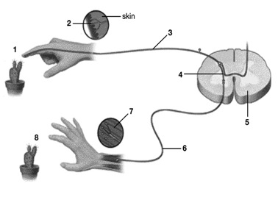
Figure 4. Reflex Arc

33. Figure 5 is a graph representing the electrical potential measured across a neuron’s membrane.

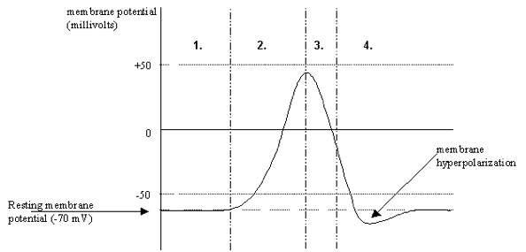

Figure 5. Membrane potential in a neuron.
Describe what is occurring at Stages 1 to 4.
(4 marks)

